Patient guide Steroid Emergency card
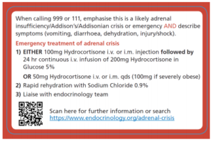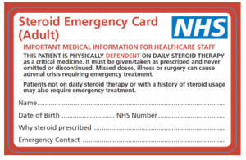
Why have I been given this card?
You have been given the NHS Steroid Emergency Card as you are taking long-term steroid treatment. It is important that any healthcare professional who treats you knows you are on long-term steroids.
You should not stop suddenly taking your steroid treatment, as you may feel very unwell if this happens. You could have weakness, dizziness, tiredness, feeling or being sick, poor appetite, weight loss and stomach pain.
What do I need to do?
You must complete the card with your own details. Keep it safe in your purse or wallet. Have it ready to show any healthcare professional you see.
Please let your family know that you carry a NHS Steroid Emergency Card. Ask them to remind you to show your card at every chance when getting treatment. This is very important if you need emergency treatment, they can tell the emergency services for you.
Do I still need to keep the blue Steroid treatment card too?
Yes, you will need to keep both, however this new NHS Steroid Emergency Card is very important. Also still wear your medic alert bracelet or necklace and keep any other emergency cards you may have.
I have lost my new card, where can I get another one from?
New or replacement NHS Steroid Emergency Cards can be obtained from your GP practice, community pharmacy or hospital. You can have more than one card if you would like to store them in different places. Please make sure the details on both cards are the same.
You can also screen shot the NHS Steroid Emergency Card and save your card. Then you can have it as screen saver on your smart phone. See further advice on how do this at: https://www.addisonsdisease.org.uk/news/new-nhs-steroid-card-released

